CCDA Case Studies

Pascal de Bruijn
2033942

 
Table of Contents
Willows and Hotchkiss Law Firm 3
What can be said about the health of the Ethernet and WAN segments? 3
Make a drawing of the current network 3
What applications are being used 4
What would you recommend to solve the WAN utilization problem 4
What would you recommend to improve the LAN utilization problem 4
What could be done to provide protection from the Internet 4
What Cisco devices could be used to provide an integrated voice and data solution 5
What network management options would you propose to Mr Sawyer 5
Would you propose a pilot to demonstrate the VoIP solution 5
What routing protocol would you recommend, and how would you change the addressing scheme 5
Draw the proposed network solution 6
Supergraphics Inc. 7
List the new applications that the customer wants to implement in the network 7
Draw a logical diagram of the existing network 7
What type of WAN technology would you recommend as a redundant solution for the T1 line between the offices 7
What services depend on the DNS server in this network 8
What solution would you recommend to give all users access to the Internet 8
What would you recommend to the customer to improve the performance on this network 8
What are the routed protocols used on this network 8
What would you recommend to use as routed protocols in the new network, and why 8
Which routing protocol can be used to support all the routed protocols of the new network 9

Willows and Hotchkiss Law Firm

What can be said about the health of the Ethernet and WAN segments?
The WAN link between the two offices averages at 85% capacity, which means it can't handle much more, so this can be considered less than healthy, and action should be undertaken to resolve the situation.
The LAN segment, which has a utilization of 45% - 60%, has users complaining about the latency. Generally a utilization above 40% should be considered unhealthy. Taking the fact into consideration that we are talking about a hubbed network, the latency is most probably caused by excessive collisions.

Make a drawing of the current network
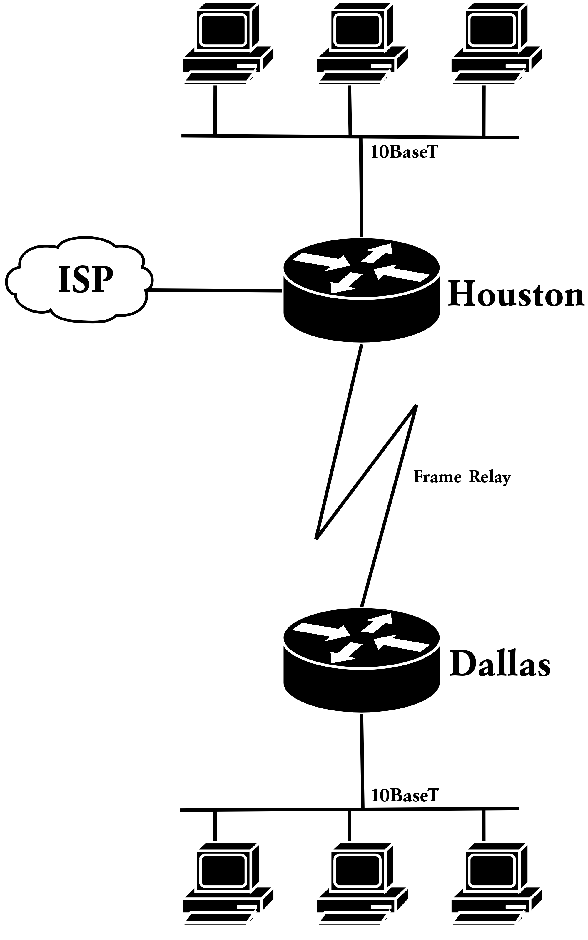

What applications are being used
Application | Protocol | Users | Servers | Latency | Throughput
Office | SMB | ~ 80 | 1 | Important
E-mail | SMTP | ~ 80 | 1 |  | Important
Web | HTTP | ~ 80 | 1 | Important
CD-ROM Server | SMB | unknown | 1 |  | Important

What would you recommend to solve the WAN utilization problem
The WAN link between the two offices averages at 85% capacity, this usually indicates that the link should be upgraded to, for example 512kb.
However, if both routers have enough processing power, link compression might provide some temporary relief, which could allow the upgrade to be postponed for a couple of months.
Currently the Dallas office is gaining Internet access through the Houston office. Using an expensive WAN link isn't the most cost effective way to get Internet access. WAN link utilization could be significantly reduced by installing a DSL line to an ISP at the Dallas office for Internet access.

What would you recommend to improve the LAN utilization problem
The LAN segment, which has a utilization of 45% - 60%, has users complaining about the latency. The latency which users are experiencing is most probably caused by excessive (layer 2) frame collisions, which results in retransmissions. This can be easily resolved by replacing the hubs with a normal (layer 2) switches.

What could be done to provide protection from the Internet
Make sure the Houston router has proper restrictive access list configured. Another layer of security could be provided by using PAT to hide internal addressing.
Also make sure the workstations have anti virus software installed and kept up to date. The E-mail server should also have anti virus software configured to block all virus infected E-mails, for maximum protection both virus scanners should be from a different vendor.

What Cisco devices could be used to provide an integrated voice and data solution
An integrated voice and data solution could be provided using Cisco voice enabled routers and Cisco Call manager.
However there are other possible solutions. Especially in a small business, Asterisk might provide a more cost-effective solution. Of course Asterisk still needs to be combined with QoS capable routers.

What network management options would you propose to Mr Sawyer
Considering the fact that Willows and Hotchkiss only have a small IT budget, no expensive software should be purchased. Enabling SNMP on all the routers and switches and monitoring them with MRTG installed on an old refurbished workstation should do the job.

Would you propose a pilot to demonstrate the VoIP solution
Considering the fact that the WAN connection is already overtaxed, piloting the VoIP solution would require a definite WAN connection upgrade, which is typically very costly. A demonstration of a prototype might be more practical for this situation.

What routing protocol would you recommend, and how would you change the addressing scheme
Currently RIPv1 is used to provide dynamic routing. While this isn't the worst choice considering the simplicity of the network, RIPv1 does have some efficiency issues. RIPv1 periodically broadcasts it's entire routing table to peers on the same segment. As RIPv1 is operating over an expensive WAN link, RIPv1 wastes costly bandwidth. Changing to a link-state or distance-vector protocol with bounded updates might alleviate some of the companies WAN utilization issues. Both EIGRP and OSPF would do very nicely. However OSPF should be preferred because it allows non-Cisco equipment to be introduced into the network at a later stage.
To protect the company against remote threats RFC1918 private IP addressing should be used in concert with PAT.

Draw the proposed network solution
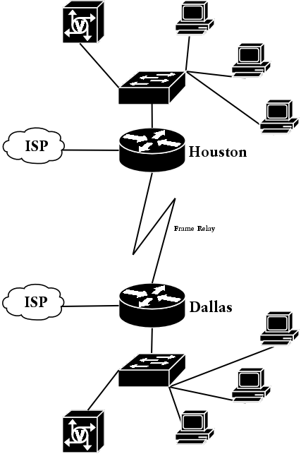

Supergraphics Inc.

List the new applications that the customer wants to implement in the network
Application | Protocol | Users | Servers | Latency | Throughput
Documentation Management and Chat Room Server | HTTP | < 200 | 1? | Important | Important
Web servers | HTTP | ? | 2 | Important
SQL Database | MSSQL | ? | 1 | Important
DNS Server | DNS | < 200 | 2? | Important
Email | SMTP, IMAP | < 200 | 1? |  | Important

Draw a logical diagram of the existing network
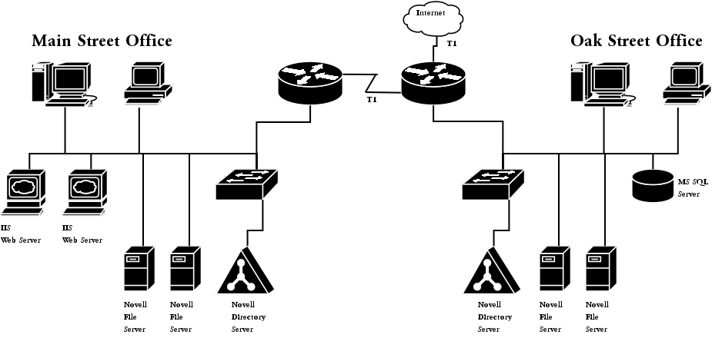

What type of WAN technology would you recommend as a redundant solution for the T1 line between the offices
Assuming the redundant line will only be used as a fail-over solution a BRI line would suffice. But when the redundant line is to be used to load-balance during high load hours a zero CIR frame relay link might offer a more cost effective solution.

What services depend on the DNS server in this network
The web-based documentation management and chat room server will depend on DNS name resolution for client to contact it. The two new Windows 2003 web servers will need a registered DNS domain to be resolved on the Internet to be reachable for normal users. And last, the E-mail system needs DNS to resolve destination domains and respective mail exchange servers (MX records).

What solution would you recommend to give all users access to the Internet
To provide Internet access for all users PAT is a highly recommended solution because it only requires a single public IP address to overload dozens of internal IPs. After implementing PAT, the remaining 29 usable address can be reserved for publicly accessible services like their web servers.

What would you recommend to the customer to improve the performance on this network
The current network performs below the maximal network health parameters. No segment has more than 20% broadcasts and segment utilization is still below 40%.
However, the 17% broadcasts is rather high, this is most likely causes by the heterogeneous network environment where each protocol stack has it's own address discovery mechanisms which most likely involve broadcasting. Reducing the number routed protocols will also very likely reduce the amount of broadcasts on the segments.

What are the routed protocols used on this network
- AppleTalk for the Macintosh workstations
- IPX/SPX for the Windows workstations
- IP for all the workstations which need Internet access and access to the documentation management system.

What would you recommend to use as routed protocols in the new network, and why
I would highly recommend consolidating all services to homogeneous IP based network by, for example, moving to a IP based Novell network. Novell has supported IP at least since release 6.
Upgrading the Macintosh workstation to Mac OS X will allow them to fully participate in a IP based network, without requiring the use of AppleTalk.

Which routing protocol can be used to support all the routed protocols of the new network
Assuming the network won't be migrated to a fully homogeneous IP network any time soon, only Cisco's proprietary EIGRP will cope with the heterogeneous network environment because EIGRP was developed to be protocol independent, using RTP as a base for EIGRP itself, and utilizing Protocol Dependant Modules to support a wide range of routed protocols.

Tobi Oetiker's Multi Router Traffic Grapher: http://people.ee.ethz.ch/~oetiker/webtools/mrtg/

